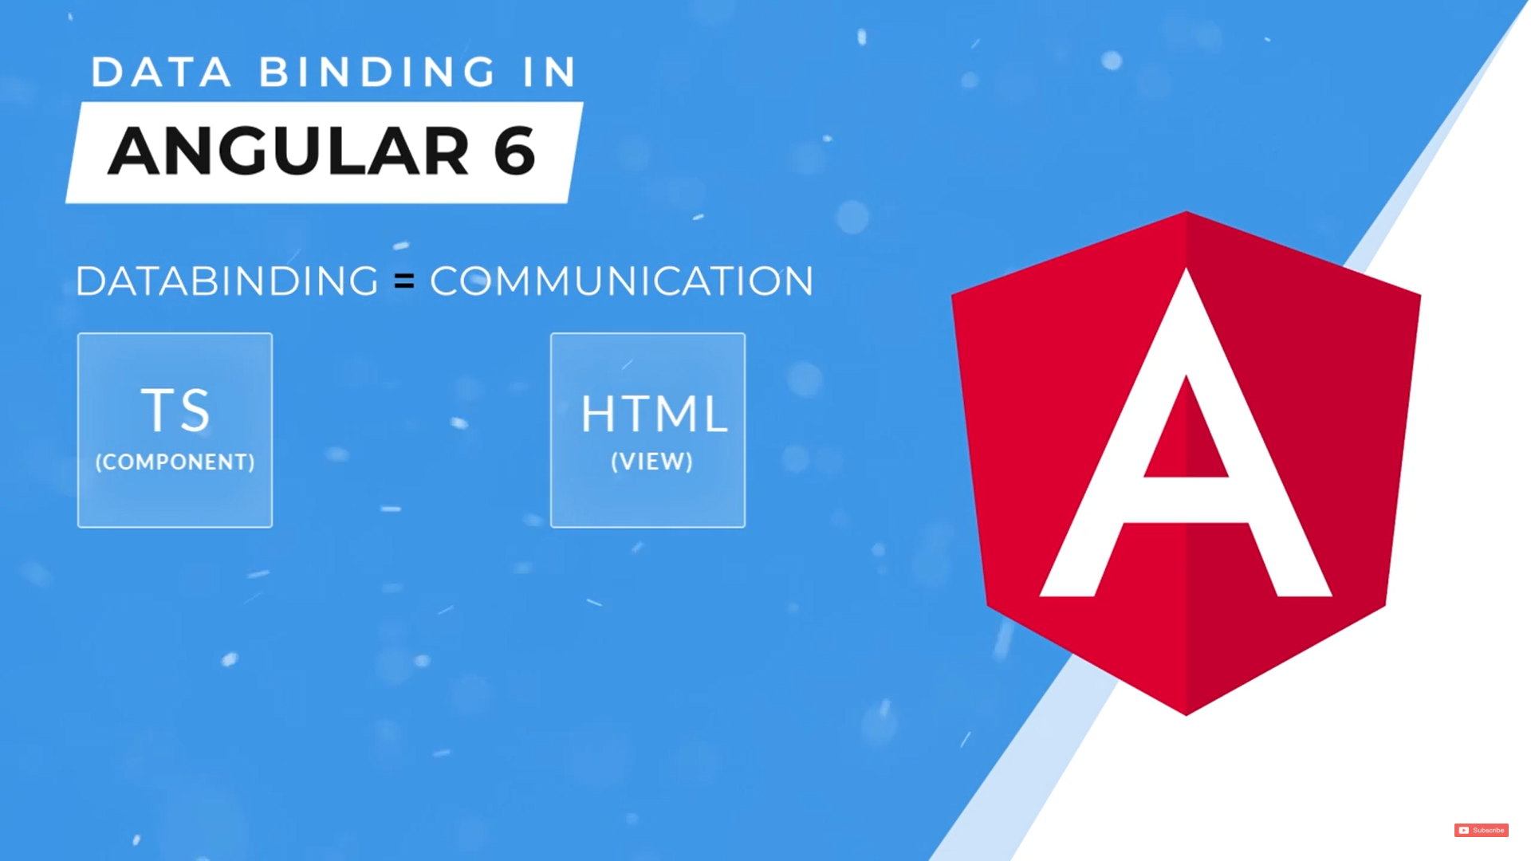

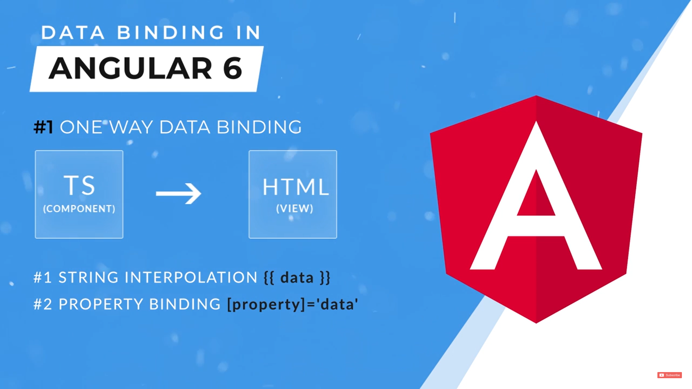

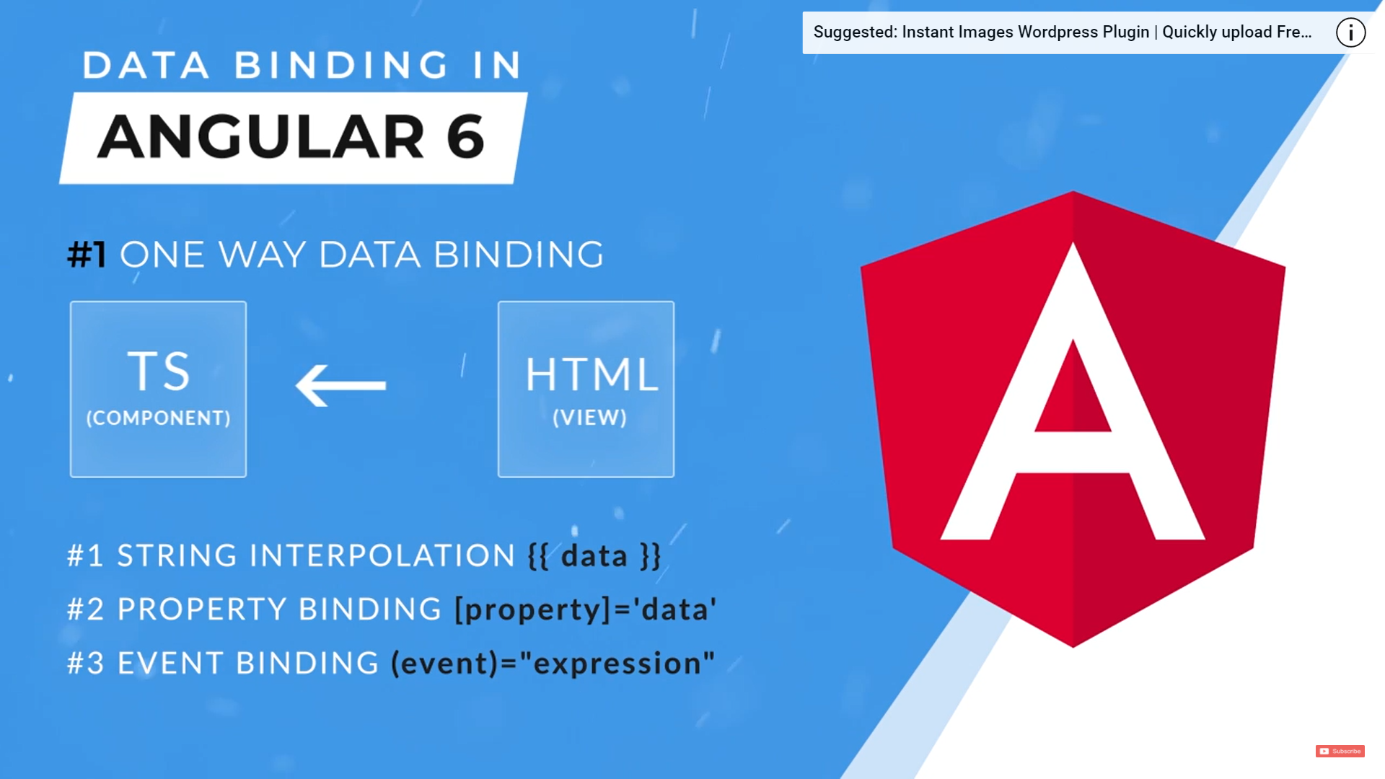

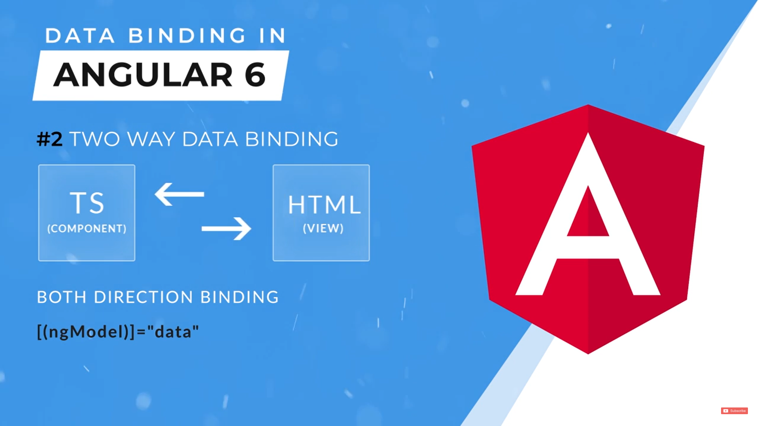

1. Interpolation

We can use only string in Interpolation

We can also use expressions

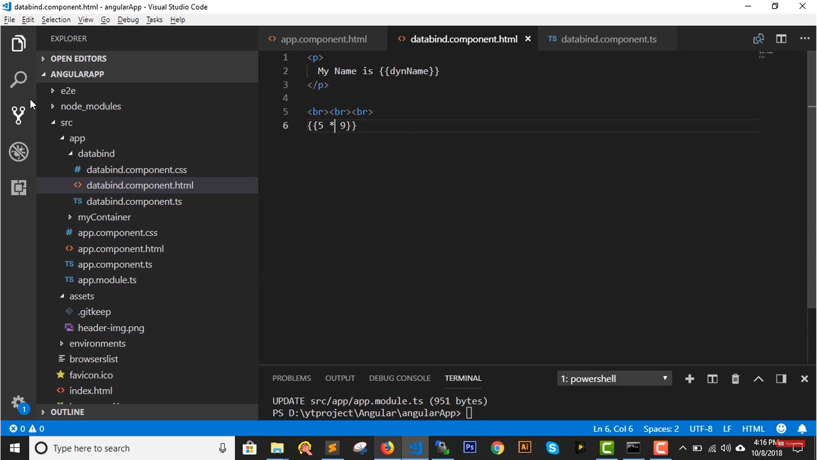

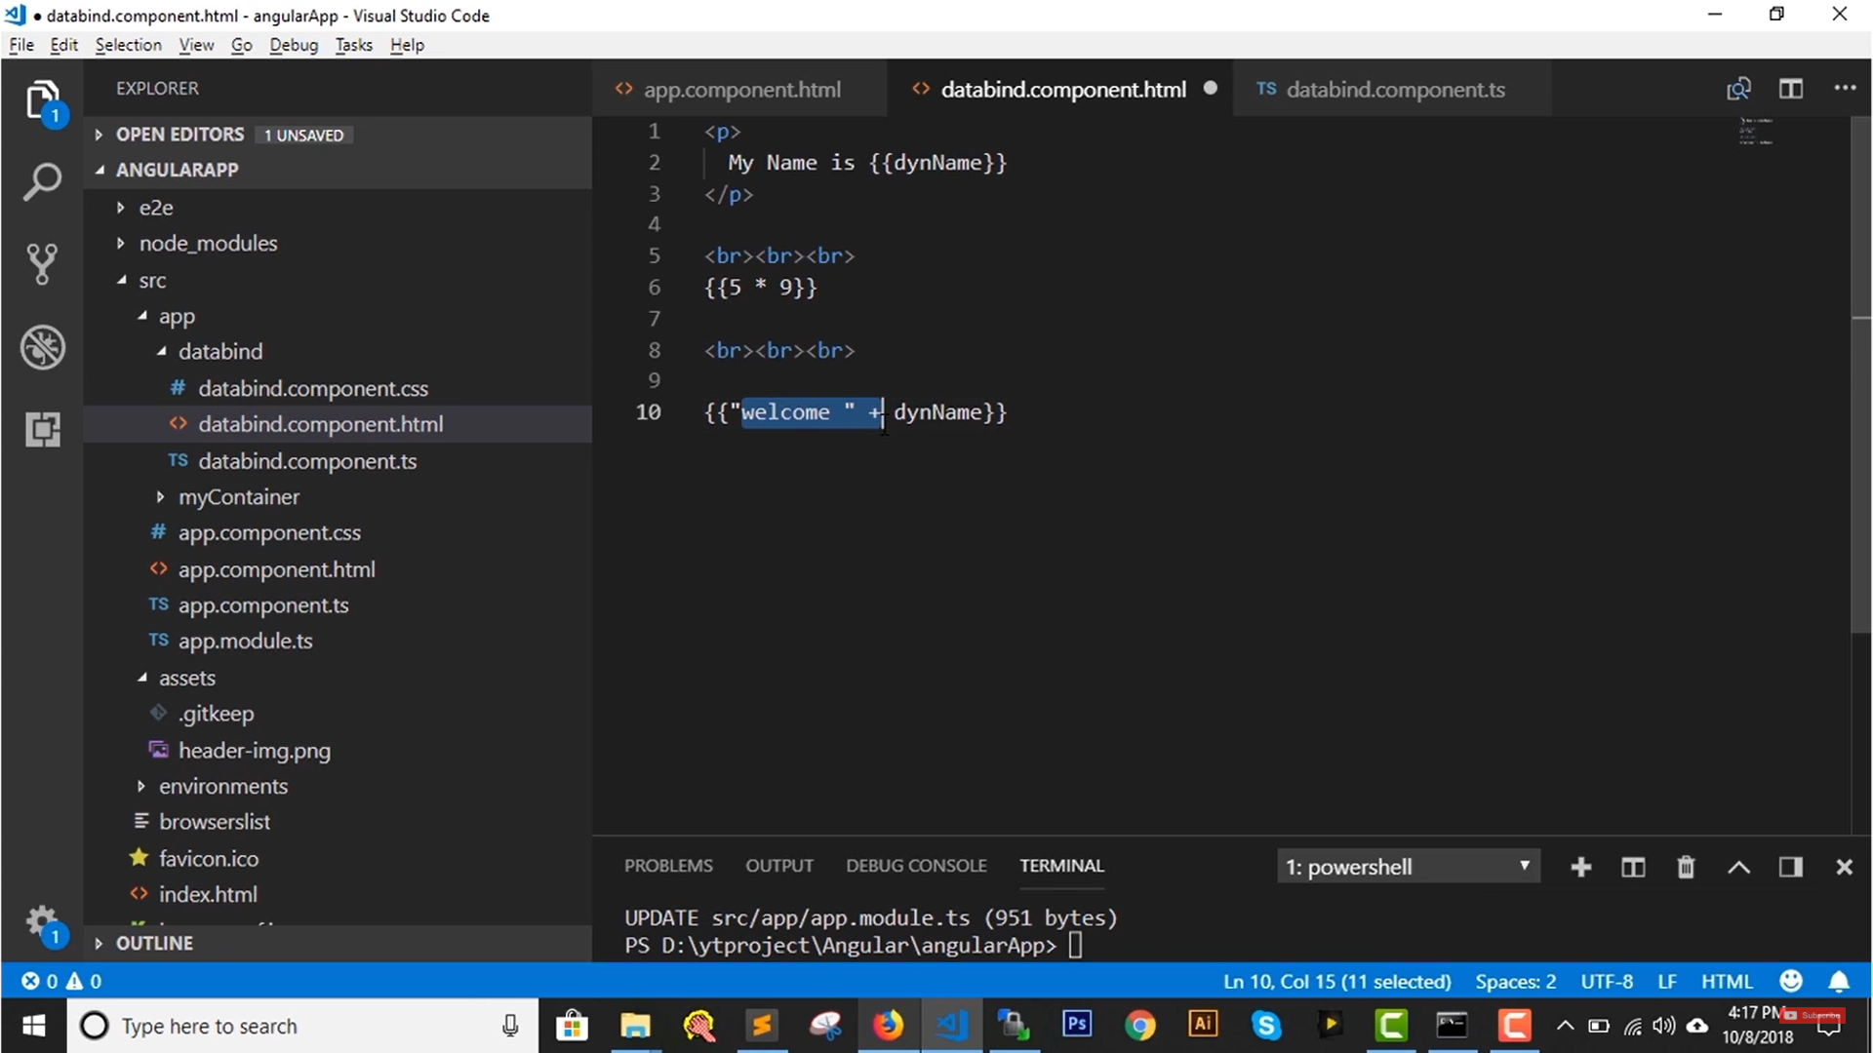

We can also use Javascript inbuilt properties & methods

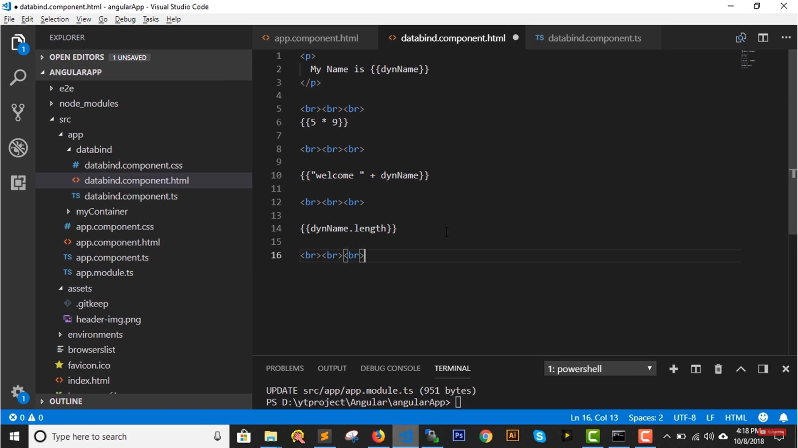

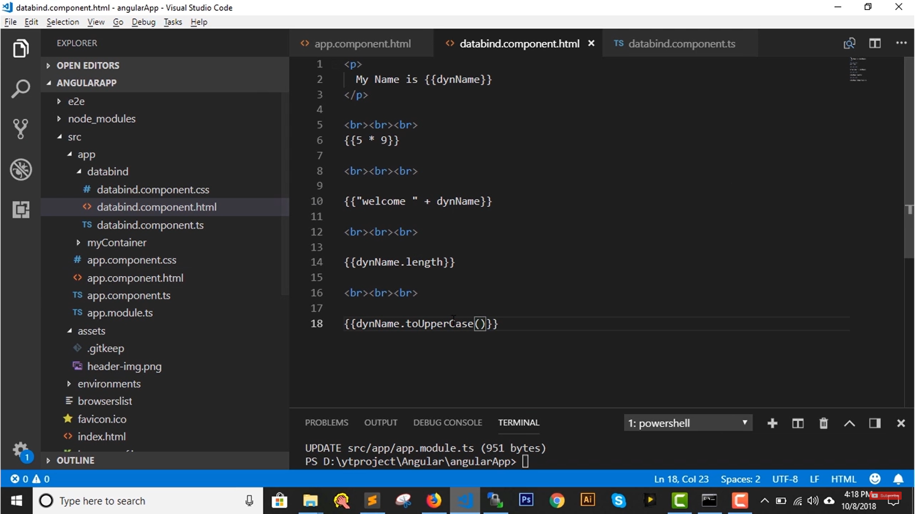

WE can also use out own methods

Class Comp

{

Name:string =”Harpreet”;

Method1()

{

Return “Hello “ + this.name;

}

We call this in html

{{ Method1()}}

In ts file

appStatus:Boolean: true

in html file

My app Status is {{appStatus? “Online”: “Offline”}}

In ts file

Status1=”Online”;

Status2 =”Offline”;

in html file

My app Status is {{appStatus? Status1: Status2}}